SYSTEM INFORMATION

Task: To know distributor deails

command: cat /etc/lsb-release

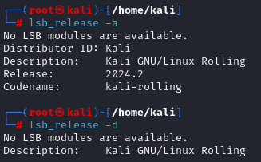

Task: To display Linux system infomation about computers software and hardware

command : uname -a



Task: To display kernel release information

command : uname -r



Task: To display hostname

command : uname -n



Task: To know how long system has been running

command: uptime

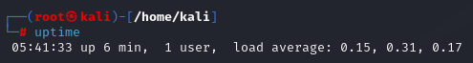

Task: To know the system name

command: hostname

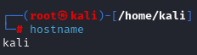

Task: To display IP address of the host

command : hostname -i



Task: To display reboot history

command: last reboot

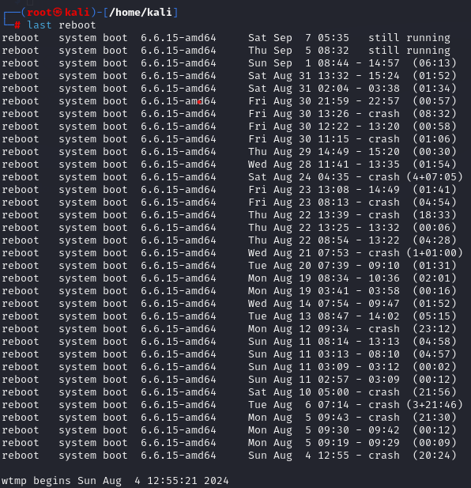

Task: To display who is online

command: w

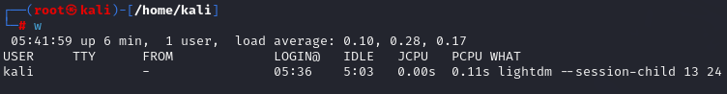

Task: To locate the executable files or location of a program from the file system

Command: which command



Task: locates the source, binary, and manuals sections for specified files

command: whereis command

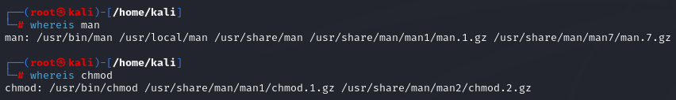

Task: To know who you logged in as

command: whoami



Task: To display hostid

command: hostid

